STUDENT MANAGEMENT SYSTEM USING AWS EC2 AND RDS
(A THREE-TIER WEB APPLICATION ARCHITECTURE)

Prepared in the partial fulfillment of the Summer Internship Program on AWS

AT



Under the guidance of
Mrs. Sumana Bethala, APSSDC
Mr. Juttuka. Lovababu, APSSDC

Submitted by
Shaik Mohammad Saeed 24BQ1A47A1 VVIT NAMBUR BATCH 1
Shaik Tanveer Ahmed 25BQ5A4712 VVIT NAMBUR BATCH 1
Tadavarthy Santosh Pranav 24BQ1A47B2 VVIT NAMBUR BATCH 1
P. Venkata Sai Manikanta 25BQ5A4710 VVIT NAMBUR BATCH 1
SK. Mohammad Suhail 24BQ1A47A2 VVIT NAMBUR BATCH 1

ACKNOWLEDGEMENT
I would like to express my heartfelt gratitude to all those who have contributed to the successful completion of my summer internship project at Andhra Pradesh Skill Development Corporation (APSSDC). This opportunity has been an enriching and transformative experience for me, and I am truly thankful for the support, guidance, and encouragement I have received along the way.
First and foremost, I extend my sincere regards to Mrs. Sumana Bethala and Mr. J. Lovababu, my supervisors and mentors, for providing me with valuable insights, constant guidance, and unwavering support throughout the duration of the internship. Their expertise and encouragement have been instrumental in shaping the direction of this project.
I would like to thank the entire team at Andhra Pradesh Skill Development Corporation (APSSDC) for fostering a collaborative and innovative environment. The camaraderie, knowledge sharing, and feedback I received from my colleagues significantly contributed to the development and success of this project.
In conclusion, I am honoured to have been a part of this internship program, and I look forward to leveraging the skills and knowledge gained to contribute positively to future endeavours.
Thank you.
Sincerely,
Shaik Mohammad Saeed 24BQ1A47A1,
(shaikmohammadsaeed493@gmail.com)
Shaik Tanveer Ahmed 25BQ5A4712,
(shaikthanveer155@gmail.com)
Tadavarthy Santosh Pranav 24BQ1A47B2,
(cyberprobe05@gmail.com)
P. Venkata Sai Manikanta 25BQ5A4710,
(manikantaparitala418@gmail.com)
SK. Mohammad Suhail 24BQ1A47A2,
(shaikmohammadsuhail1006@gmail.com)

ABSTRACT
This project presents the design and implementation of a Student Management System deployed on Amazon Web Services (AWS) using a three-tier architecture built around Amazon EC2 and Amazon RDS. The primary goal is to demonstrate how a traditional, database-driven web application can be hosted securely and reliably on the cloud by combining compute, networking, and managed database services within a custom Virtual Private Cloud (VPC).
The system allows an administrator to manage student records — including registration, attendance, and academic marks — through a web application hosted on an Amazon EC2 instance running Apache and PHP. The application connects to an Amazon RDS (MySQL) instance that stores all student data. To ensure security and proper network isolation, the infrastructure is built on a custom VPC with a public subnet hosting the web server and a private subnet hosting the database. A NAT Gateway allows resources in the private subnet to reach the internet for updates without being directly exposed, while Security Groups enforce strict, least-privilege access rules between the tiers.
This architecture reflects a classic three-tier web application design: a presentation/web tier (EC2), an application logic tier (PHP running on the same EC2 instance), and a data tier (Amazon RDS). By separating the public-facing web server from the private database layer, the system achieves a strong security posture while remaining simple to deploy, monitor, and scale.
The project demonstrates practical, hands-on understanding of core AWS networking and compute concepts — including VPC design, subnetting, route tables, NAT Gateways, and Security Groups — while solving a real-world use case: enabling educational institutions to manage student information in a centralized, cloud-hosted, and secure environment.

TABLE OF CONTENTS
S.No Content Pg.No
1. INTRODUCTION 6
2. METHODOLOGY 7
3. TECHNOLOGY STACK 10
4. SYSTEM DESIGN / ARCHITECTURE 12
5. IMPLEMENTATION 15
6. RESULTS 17
7. CONCLUSION 19

1. INTRODUCTION
In today's educational institutions, the accurate and timely management of student information — admissions, attendance, academic performance, and personal records — is fundamental to smooth administrative operations. This project, titled Student Management System using AWS EC2 and RDS, applies core AWS compute, networking, and database services to build a secure, reliable, and cloud-hosted web application for managing student data. It illustrates how a conventional three-tier web application can be architected on the cloud to achieve both operational simplicity and strong security isolation.
Traditional, on-premises student management solutions are often constrained by limited scalability, high maintenance overhead, and vulnerability to hardware failure. Institutions require a system that is always available, protects sensitive student data, and can be maintained with minimal manual intervention. This project addresses these challenges by hosting the application on Amazon EC2 within a carefully designed Amazon VPC, and by storing all student records in a managed, private Amazon RDS database instance.
The system is designed around the well-established three-tier architecture pattern. The presentation and application logic reside on an EC2 instance placed in a public subnet, making the web application accessible to administrators and staff over the internet. The data tier, powered by Amazon RDS running MySQL, resides in a private subnet that has no direct route to the internet, ensuring that student records cannot be accessed directly from outside the network. Communication between the two tiers is tightly controlled using Security Groups, while a NAT Gateway allows the private subnet to reach the internet for software updates and patches without exposing the database publicly.
What distinguishes this project is its emphasis on foundational AWS networking concepts — VPC design, public and private subnetting, route tables, NAT Gateways, and Security Groups — applied to a practical, real-world application. Rather than relying on a fully serverless or managed platform, this implementation demonstrates how to responsibly design and secure infrastructure at the network layer, which is a core skill in cloud architecture and administration.
This report provides a comprehensive overview of the system's design, architecture, and implementation, describing the reasoning behind key networking and security decisions and the steps taken to deploy a functioning Student Management System on AWS. The architecture is intentionally modular, allowing for future enhancements such as Elastic Load Balancing for high availability, Auto Scaling for the web tier, or Amazon S3 integration for storing student documents and photographs.

2. METHODOLOGY
The development of the Student Management System followed a structured and iterative methodology to ensure that the final solution met both functional and infrastructural requirements. The methodology was divided into key phases, including requirements gathering, system design, implementation, testing, deployment, and refinement. Each phase was designed to align with AWS best practices for secure and scalable network architecture. The following subsections outline each phase in detail.

2.1. Requirements Gathering
The project began with an analysis of the functional and infrastructural requirements for a secure, cloud-hosted student management application. Discussions with mentors helped define the core objectives: build a web-based application for managing student records, host it on AWS using a proper network architecture, and ensure that the database layer is isolated from direct public access. The system was designed to support student registration, record updates, attendance tracking, and marks management through a simple administrator interface.

2.2. Design
Based on the identified requirements, a three-tier, network-isolated architecture was designed using core AWS services. The design placed the web/application tier on an Amazon EC2 instance within a public subnet and the database tier on an Amazon RDS instance within a private subnet, both inside a custom Amazon VPC. A NAT Gateway was planned to provide outbound internet access for the private subnet, and Security Groups were designed to strictly control inbound and outbound traffic between tiers, following the principle of least privilege.

2.3. Implementation
The implementation phase focused on translating the design into a working deployment. A custom VPC was created with separate public and private subnets across an Availability Zone. An EC2 instance was launched in the public subnet, configured with Apache, PHP, and the necessary application code to serve the Student Management System. An Amazon RDS MySQL instance was launched in the private subnet to store student records. Security Groups were configured so that the EC2 instance could only accept web traffic from permitted sources, and the RDS instance could only accept database connections from the EC2 instance's Security Group.

2.4. Database Management
A relational approach was adopted for structured and consistent data storage using Amazon RDS (MySQL). The database schema was designed to include tables for student records, attendance, and marks, with a unique student identifier serving as the primary key. The schema supports efficient queries for record retrieval, updates, and reporting, and integrates directly with the PHP application running on the EC2 instance. Data integrity was maintained through input validation at the application layer and appropriate use of primary and foreign keys within the schema.

2.5. Testing
Multiple levels of testing were carried out to validate functionality, network configuration, and security. Application-level testing verified that student records could be created, viewed, updated, and deleted correctly through the web interface. Network testing confirmed that the EC2 instance was reachable from the internet while the RDS instance remained inaccessible from outside the VPC. Security Group rules were tested to confirm that only authorized traffic between the web tier and database tier was permitted, and that all other access attempts were correctly denied.

2.6. Deployment
The system was deployed entirely on AWS using the Management Console. The VPC, subnets, route tables, Internet Gateway, and NAT Gateway were configured to establish proper network isolation and connectivity. The EC2 instance was deployed with the appropriate Security Group and IAM permissions, and the RDS instance was deployed with restricted access limited to the application tier. The deployment process was structured to allow the web application to be reachable publicly while keeping the database layer fully private.

2.7. Iterative Refinement
Throughout the development cycle, iterative feedback loops were established to continuously refine the system. Adjustments were made to Security Group rules, subnet route tables, and application configuration based on testing results and mentor feedback. The architecture was reviewed periodically to ensure adherence to AWS networking and security best practices. This iterative process ensured that the final system remained secure, functional, and ready for future enhancements such as load balancing or auto scaling.
The methodology adopted for the development of this Student Management System ensured a secure, well-architected, and functional solution. By following a structured, network-first approach, the project successfully demonstrates the practical application of core AWS compute and networking services to a real-world administrative problem.

3. TECHNOLOGY STACK
The Student Management System was developed using a combination of AWS infrastructure services and standard web development technologies. The following technologies and services were used throughout the implementation:

3.1. Cloud Platform
- Amazon Web Services (AWS): The entire project is hosted on AWS, leveraging its compute, networking, and managed database services.

3.2. AWS Services
- Amazon VPC: Provides an isolated virtual network for hosting the application, with custom public and private subnets.
- Amazon EC2: Hosts the web server and application logic within the public subnet of the VPC.
- NAT Gateway: Enables instances in the private subnet (such as the RDS database) to access the internet for updates, without being directly reachable from outside.
- Security Groups: Act as virtual firewalls, controlling inbound and outbound traffic at the instance level for both EC2 and RDS.
- Amazon RDS (MySQL): A managed relational database service used to store student records, attendance, and marks data in the private subnet.

3.3. Web Server & Application
- Apache HTTP Server: Installed on the EC2 instance to serve the web application.
- PHP: Used for server-side application logic, including form handling and database interaction.
- HTML, CSS, and JavaScript: Used to build the front-end interface of the Student Management System.

3.4. Database
- MySQL (Amazon RDS): Relational database engine used to store and manage structured student data.

3.5. Security & Access
Security Groups and subnet-level network isolation were configured to allow only the necessary traffic between tiers, following the principle of least privilege. The database tier was placed in a private subnet with no direct route to the Internet Gateway, and access was restricted to the EC2 Security Group only.

3.6. Monitoring & Logging
- Amazon CloudWatch: Used to monitor EC2 instance health, resource utilization, and RDS performance metrics.

4. SYSTEM DESIGN / ARCHITECTURE
The Student Management System is designed as a secure, three-tier web application hosted entirely within a custom Amazon VPC. The architecture separates the publicly accessible web tier from the privately isolated data tier, ensuring that student records are never directly exposed to the internet. The system follows a multi-tier design, comprising the networking layer, the web/application tier, the data tier, and the security and monitoring layer, all built using core AWS infrastructure services.
This section outlines the core components and their interactions in the architecture.
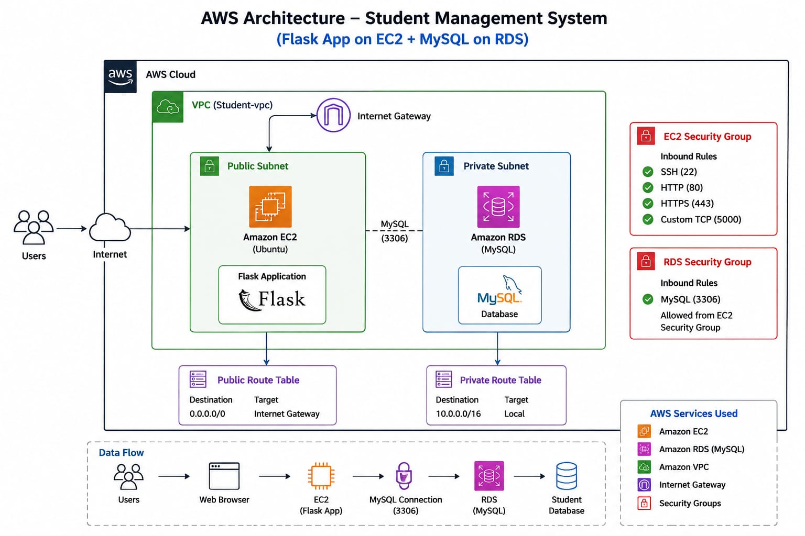

4.1. Networking Layer – Amazon VPC
The foundation of the architecture is a custom Amazon VPC, which provides a logically isolated network environment for the application. Within the VPC, two subnets are created: a public subnet, which hosts the EC2 web server and has a route to the Internet Gateway, and a private subnet, which hosts the RDS database and has no direct route to the internet. This separation ensures that the database tier is shielded from direct public access while the web tier remains reachable by administrators and staff.
- Custom VPC with defined CIDR range for full control over the network
- Public subnet for internet-facing resources (EC2 web server)
- Private subnet for protected resources (RDS database)
- Route tables configured to direct traffic appropriately for each subnet
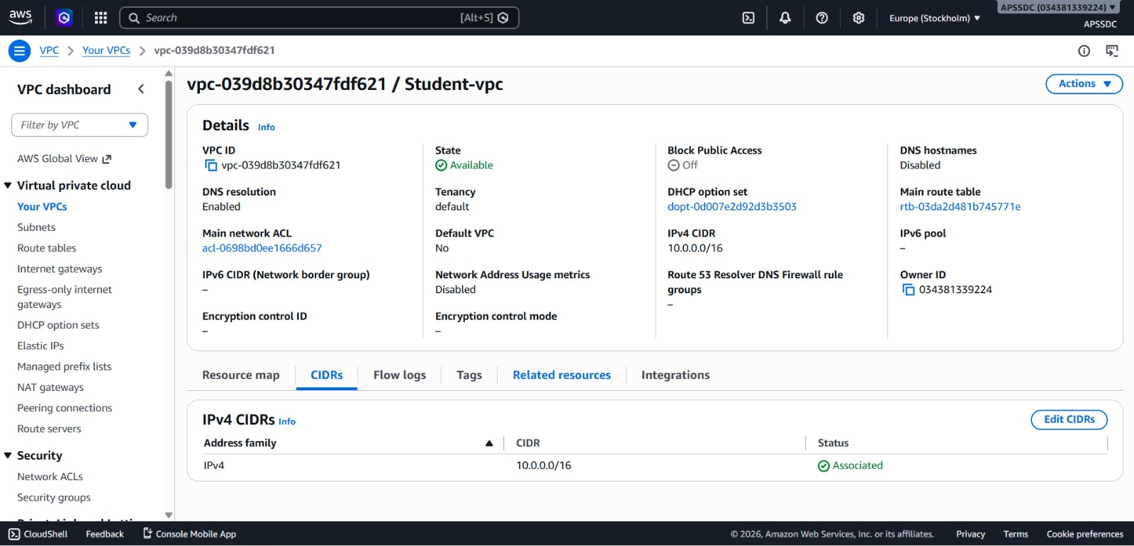
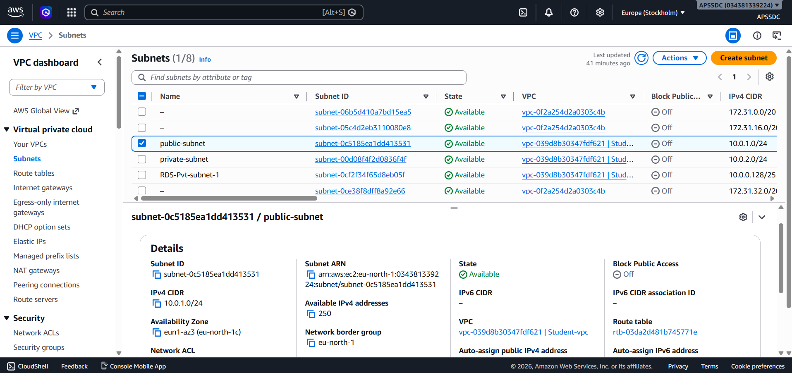
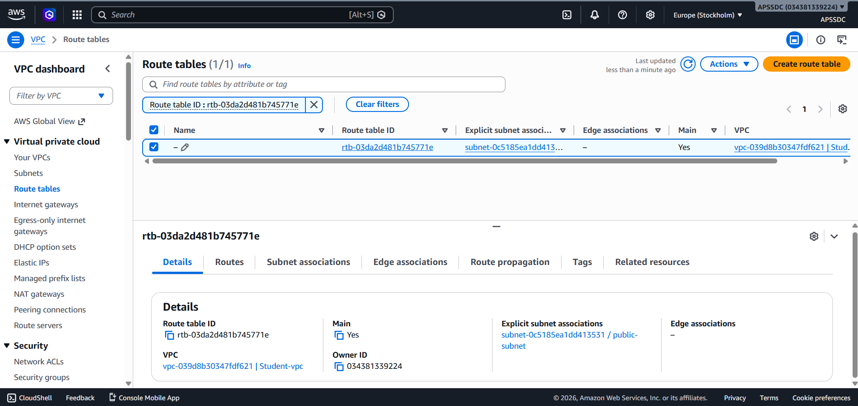
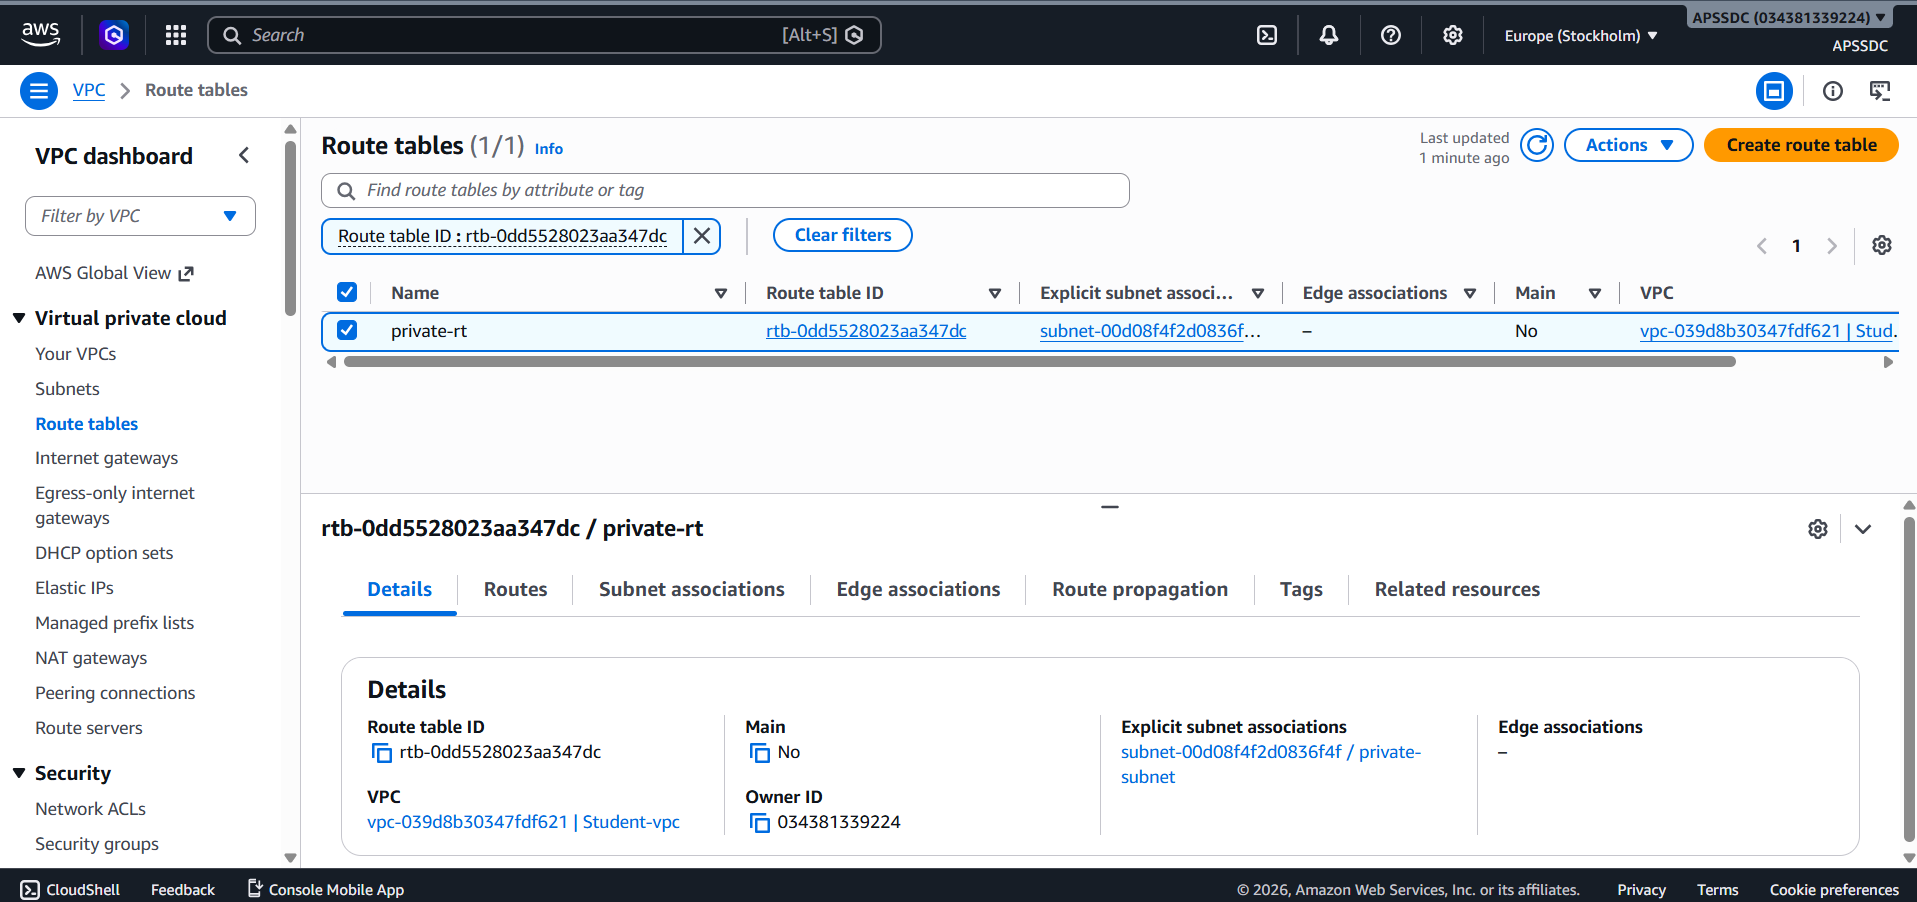
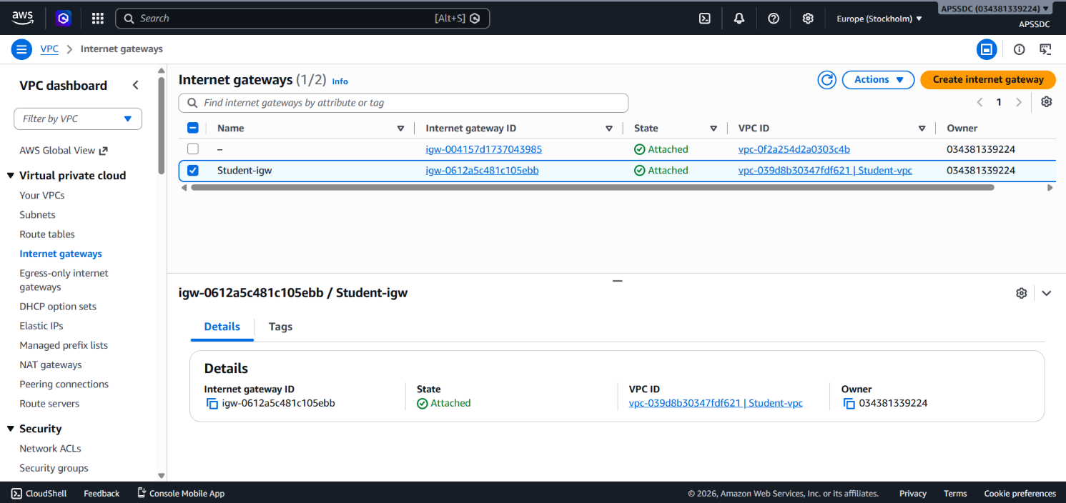

4.2. Web / Application Tier – Amazon EC2
An Amazon EC2 instance, placed in the public subnet, hosts the Student Management System web application. This instance runs Apache and PHP, and serves the front-end interface used by administrators to manage student records. The EC2 instance is assigned a public IP address (or an Elastic IP) so that it can be accessed over the internet, while all outbound requests to the database occur over the private, internal VPC network.
- Runs Apache HTTP Server and PHP application logic
- Handles student registration, record updates, attendance, and marks entry
- Connects securely to the RDS instance using internal VPC networking
- Publicly accessible via HTTP/HTTPS through the Internet Gateway
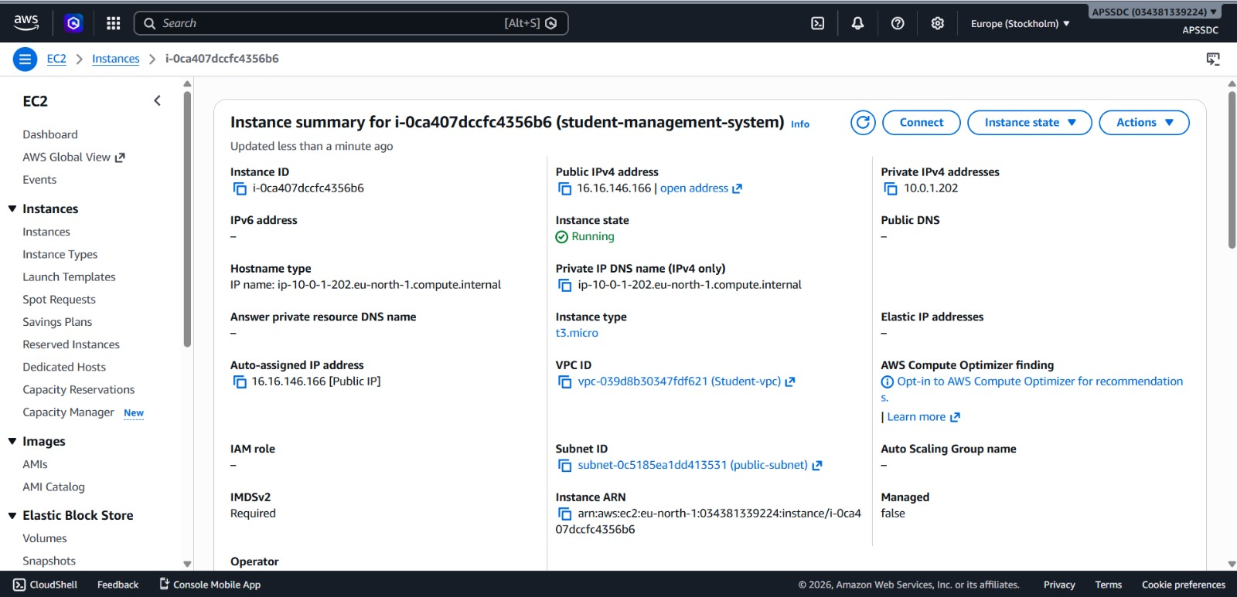
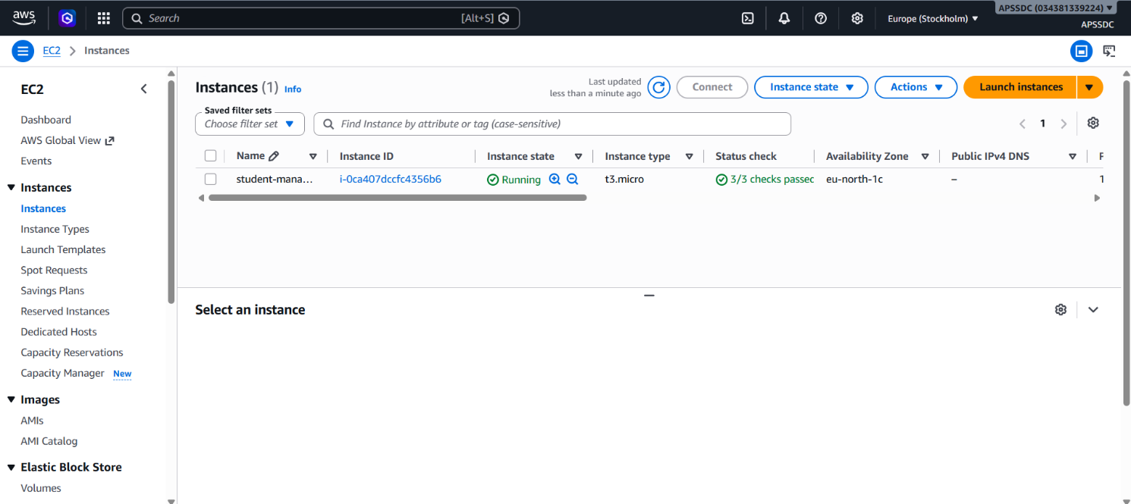
4.3. Data Tier – Amazon RDS (Private Subnet)
Student data is stored in an Amazon RDS instance running MySQL, deployed within the private subnet. Because the private subnet has no route to the Internet Gateway, the database cannot be reached directly from the public internet. The only path to the database is through the EC2 instance, and only traffic on the MySQL port from the EC2 Security Group is permitted.
- Stores structured student records: personal details, attendance, and marks
- Deployed in the private subnet for maximum data protection
- Accessible only from the EC2 instance's Security Group
- Managed service handling backups, patching, and maintenance
- 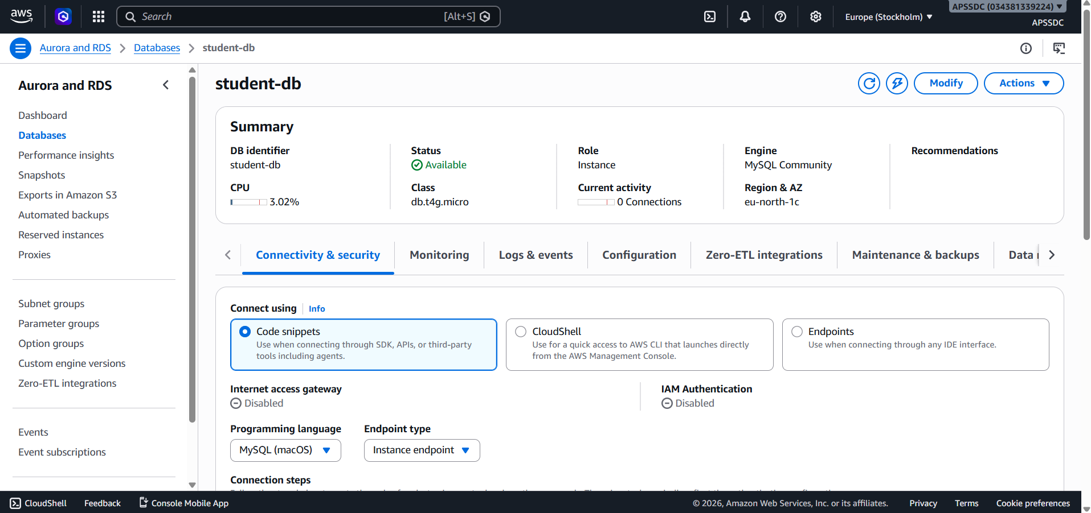
- 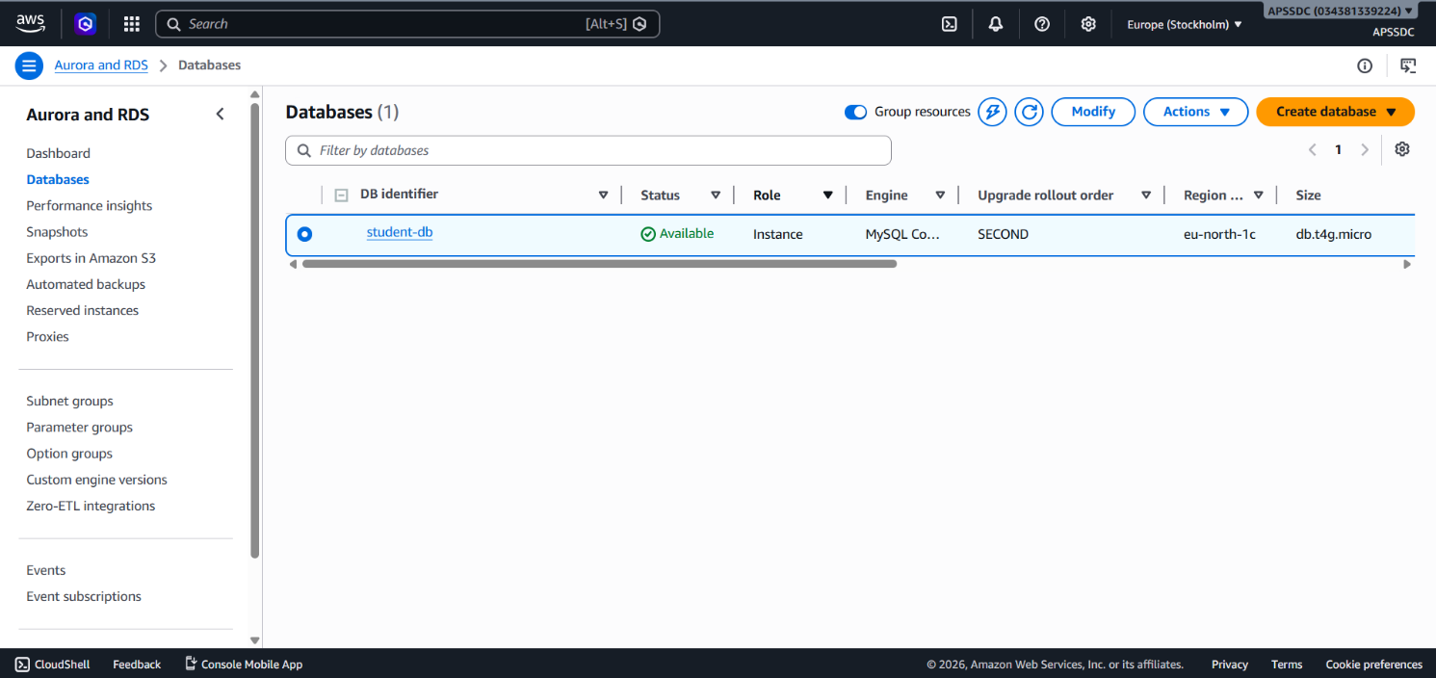

4.4. Security Groups
Security Groups function as virtual, stateful firewalls attached to the EC2 and RDS instances. They are configured following the principle of least privilege, ensuring that each tier can only communicate with the tiers it is explicitly permitted to interact with.
- EC2 Security Group: Allows inbound HTTP/HTTPS (and SSH from trusted IPs only) from the internet
- RDS Security Group: Allows inbound MySQL traffic only from the EC2 Security Group
- All other inbound traffic to the database tier is denied by default
- Outbound rules restricted to only what each tier requires
- 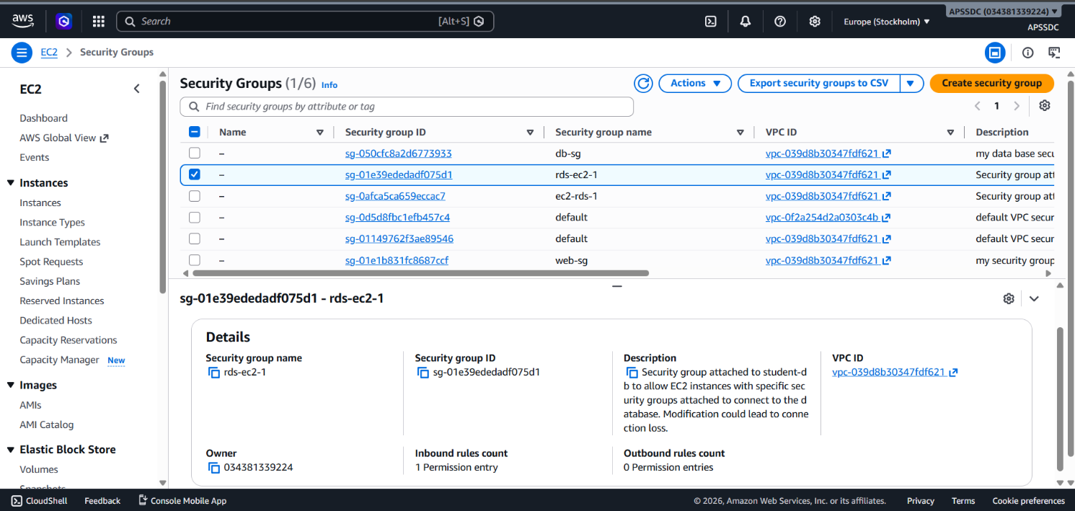
- 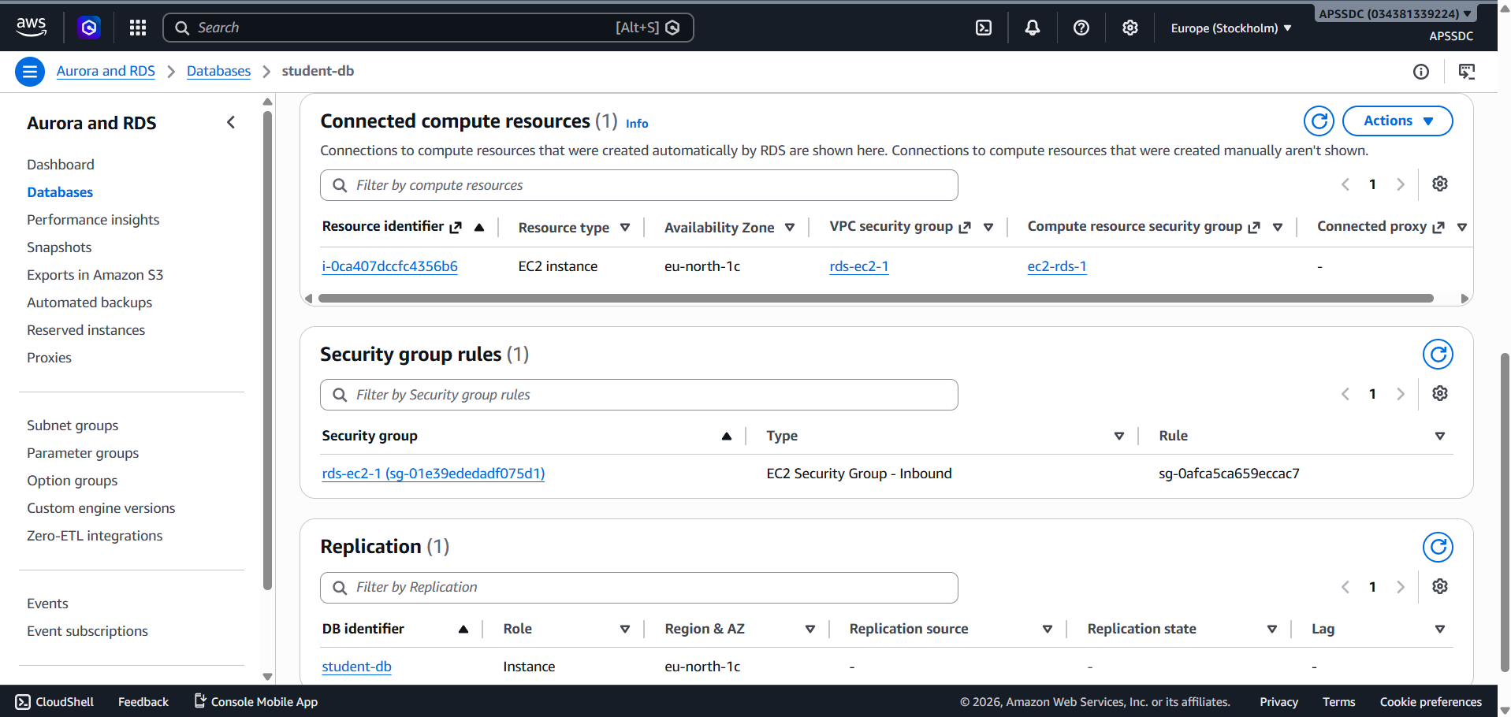

4.5. Monitoring – Amazon CloudWatch
Amazon CloudWatch is integrated to monitor the health and performance of both the EC2 instance and the RDS database, providing visibility into resource utilization, connection counts, and potential issues.
- Tracks EC2 CPU utilization, network traffic, and status checks
- Monitors RDS metrics such as CPU utilization, storage, and database connections
- Supports alarms for abnormal activity or resource exhaustion

5. IMPLEMENTATION
The implementation of the Student Management System translates the architectural design into a fully functional, securely networked web application on AWS. This section outlines how each AWS service and application component was configured and connected to deliver a working three-tier system.

5.1. VPC and Subnet Configuration
A custom VPC was created with a defined CIDR block. Within this VPC, one public subnet and one private subnet were configured in the same Availability Zone. An Internet Gateway was attached to the VPC and associated with the public subnet's route table, allowing resources in the public subnet to communicate with the internet.

5.2. EC2 Instance – Web and Application Tier
An Amazon EC2 instance was launched within the public subnet. Apache and PHP were installed on the instance, and the Student Management System application code was deployed to the web server's document root. The instance was configured with an Elastic IP for a stable public-facing address, and connection details for the RDS database (endpoint, credentials, database name) were stored securely within the application's configuration.
Key application features implemented:
- Add new student records (name, roll number, course, contact details)
- View, search, and filter existing student records
- Update and delete student information
- Record and view daily attendance
- Enter and view subject-wise marks for each student
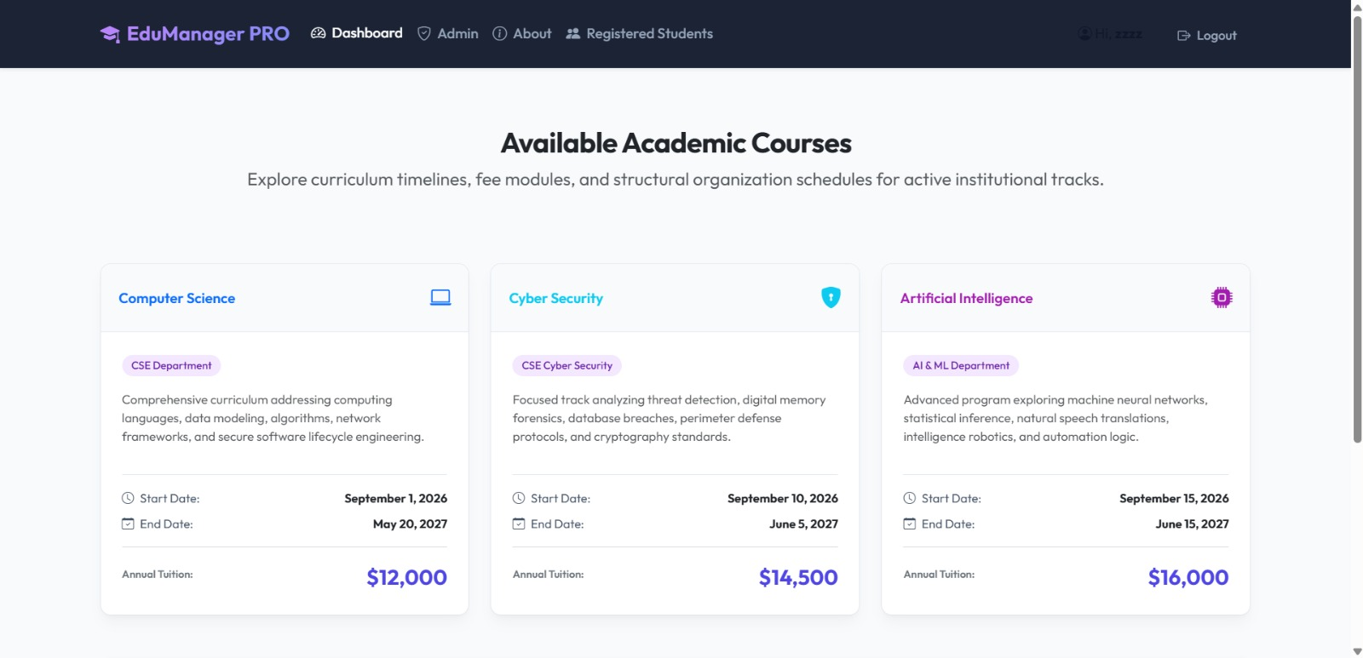
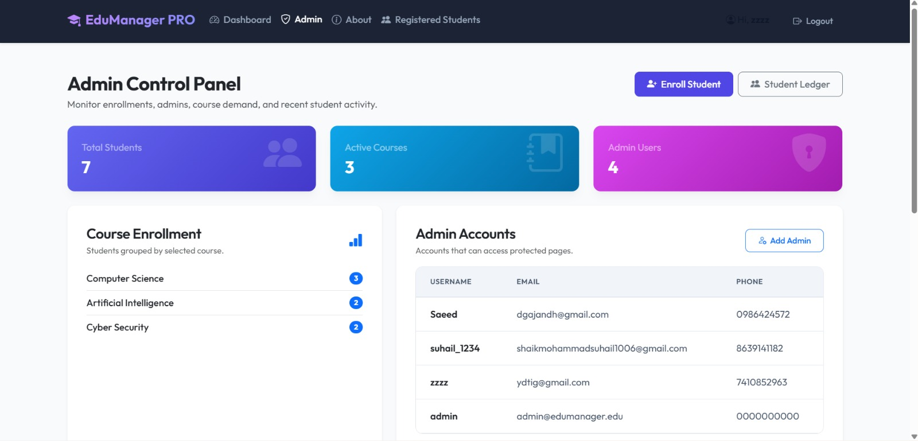

5.3. RDS Instance – Data Tier
An Amazon RDS instance running MySQL was launched within the private subnet, using a DB subnet group scoped to the private subnet. The database schema was created with tables for students, attendance, and marks, linked through the student's unique identifier. The RDS instance was configured to accept connections only from the EC2 instance's Security Group, ensuring the database remains unreachable from the public internet.
Core database tables:
- students — StudentID (Primary Key), Name, Course, ContactNumber, Email
- attendance — AttendanceID (Primary Key), StudentID (Foreign Key), Date, Status
- marks — MarkID (Primary Key), StudentID (Foreign Key), Subject, Score
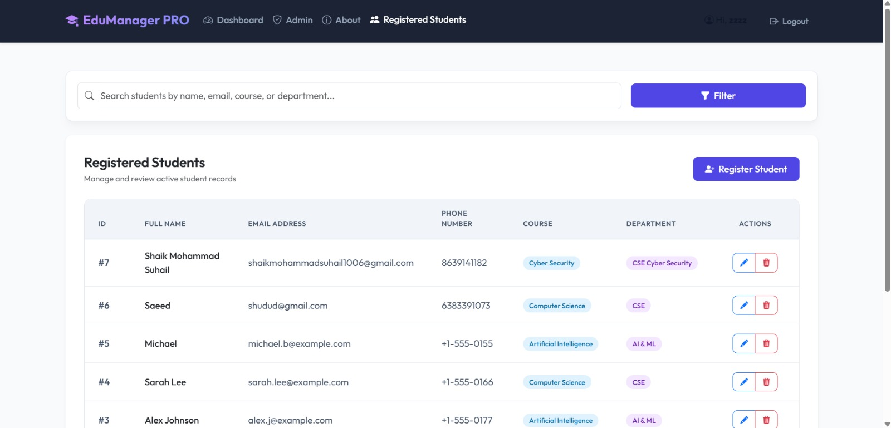

5.4. Security Group Configuration
Two Security Groups were configured to enforce network-level access control. The EC2 Security Group permits inbound traffic on HTTP (port 80) and HTTPS (port 443) from any source, and SSH (port 22) restricted to trusted administrator IP addresses only. The RDS Security Group permits inbound traffic on the MySQL port (3306) exclusively from the EC2 Security Group, ensuring no other resource can query the database directly.

5.5. Monitoring with Amazon CloudWatch
Amazon CloudWatch was configured to collect metrics from both the EC2 instance and the RDS database. Dashboards were used to track instance CPU utilization, network throughput, and database connection counts, giving visibility into system health and performance during testing and operation.
The successful implementation of this system demonstrates how core AWS networking and compute services can be combined to build a secure, three-tier web application. The clear separation between the public web tier and the private data tier ensures that student records remain protected, while the overall design remains simple to operate and extend.

6. RESULTS
The implementation of the Student Management System yielded several successful outcomes that validate the design objectives of security, functionality, and reliability. The system was tested under multiple scenarios to confirm correct network isolation, application behaviour, and data integrity.

6.1. Functional Student Record Management
Administrators were able to successfully add, view, update, and delete student records through the web application hosted on the EC2 instance. Attendance and marks data were correctly recorded and retrieved from the RDS database, confirming that the application and database tiers were communicating correctly over the internal VPC network.

6.2. Verified Network Isolation
Testing confirmed that the RDS instance, deployed in the private subnet, could not be reached directly from the public internet, even when attempting to connect using its endpoint from outside the VPC. All database access succeeded only when routed through the EC2 instance, validating the effectiveness of the subnet design and Security Group configuration.

6.3. Secure and Controlled Access
Using Security Groups, access between tiers was tightly controlled: the EC2 instance accepted only web and restricted SSH traffic, while the RDS instance accepted database traffic only from the EC2 Security Group. This confirmed adherence to the principle of least privilege across the architecture.
Testing scenarios included:
- Accessing the web application from various external networks
- Attempting direct connections to the RDS endpoint from outside the VPC
- Simulating concurrent student record submissions
All scenarios behaved as expected, with the database remaining inaccessible from outside the VPC in every case.

6.4. System Monitoring
Through Amazon CloudWatch, the system was monitored for EC2 CPU and network utilization, and RDS connection counts and performance metrics. Monitoring data confirmed stable resource usage throughout testing, with no unexpected spikes or failures.

6.5. User Experience and Functionality
The system provides a straightforward experience for administrative staff:
- A single web interface for all student record operations
- Fast response times for record retrieval and updates
- Data remains secure and isolated within the private subnet at all times
The overall results demonstrate that the Student Management System meets its intended goals of security, functionality, and reliability. The three-tier architecture is stable and ready for real-world use in an institutional setting, with clear opportunities for further scaling and enhancement.

7. CONCLUSION
The successful development and deployment of the Student Management System using AWS EC2 and RDS demonstrate the practicality of a well-architected, three-tier web application built on core AWS networking and compute services. By leveraging Amazon VPC, EC2, RDS, NAT Gateway, and Security Groups, the system achieves its core objectives: providing a functional, web-based platform for managing student records while ensuring that sensitive data remains securely isolated from direct public access.
The project highlights the value of thoughtful network architecture in cloud computing, including the separation of public and private subnets, controlled outbound connectivity through a NAT Gateway, and strict access control through Security Groups. The use of Amazon RDS provides reliable, managed relational storage for student data, while the EC2-hosted web application delivers a simple and effective interface for day-to-day administrative tasks.
Throughout the development lifecycle, careful attention was given to network security, least-privilege access, and system monitoring. Testing confirmed that the database tier remains inaccessible from outside the VPC under all conditions, validating the core security objective of the architecture.
Beyond its current functionality, the project lays a strong foundation for future enhancements, such as:
- Introducing an Application Load Balancer and Auto Scaling for high availability
- Using Amazon S3 to store student documents, ID photos, and certificates
- Adding Multi-AZ deployment for the RDS instance to improve fault tolerance
- Implementing role-based access control for administrators, faculty, and students
In conclusion, this project serves as a practical blueprint for deploying secure, database-driven web applications on AWS, particularly in domains where data protection and network isolation are critical. It showcases how foundational AWS networking and compute services can be combined to build a reliable, secure, and institution-ready Student Management System.
THE STUDENT MANAGEMENT SYSTEM APP
EDU MANAGER PRO APP




